A Study Evaluating the Role of Big Data Analytics in the Healthcare Sector of the UK

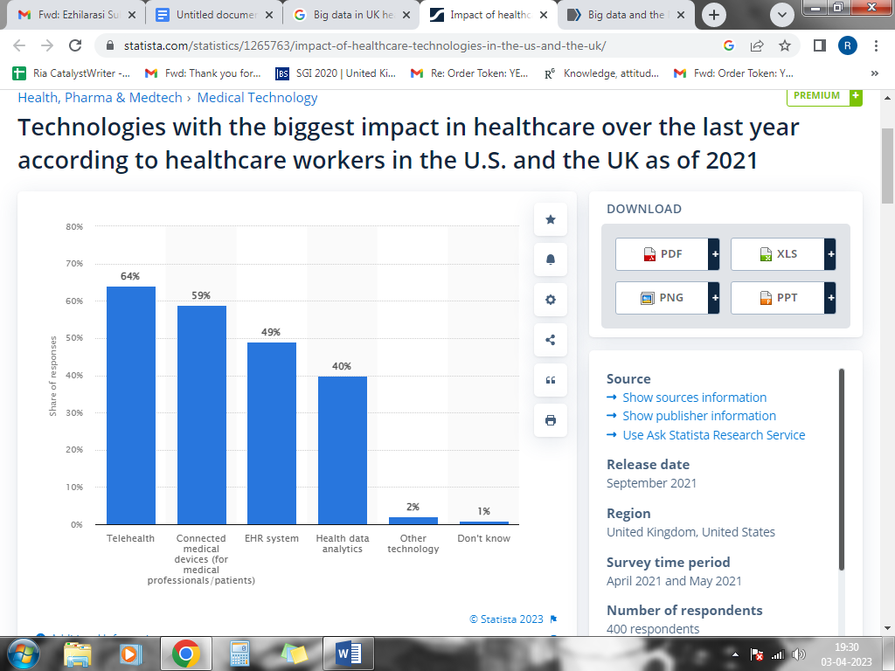
Technologies affecting healthcare
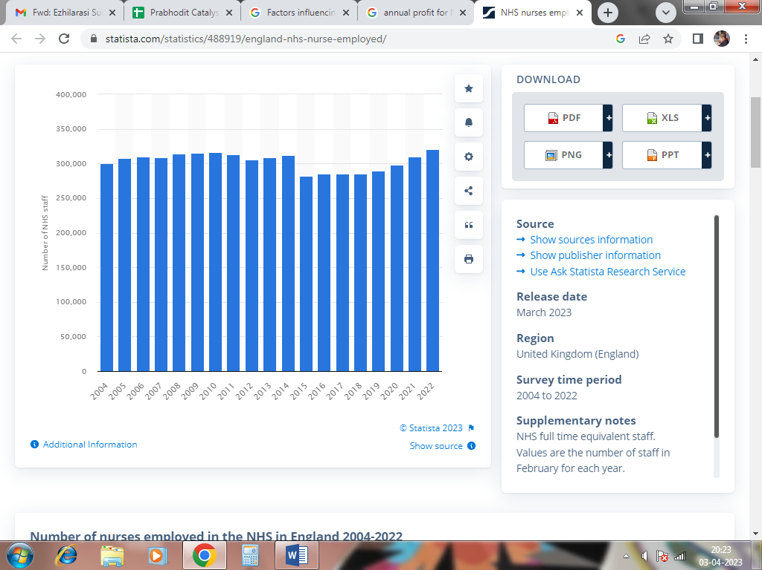
Annual Nurses Employed at NHS

